**TUGAS TAMBAHAN KELAS XII BAHASA & SASTRA INGGRIS SEMESTER GANJIL TP 2023 -2024**



**Muhammad Syakir Ardiansyah**

**XII MIPA 2**

**SMA NEGERI 99 JAKARTA**

**Jalan Cibubur II, Kel. Cibubur, Kec. Ciracas– Jakarta Timur**

***TEXT TYPE***

1. History

Historical story texts are texts that explain and tell about facts and events from the past which are the background to the occurrence of something that has historical value. Historical story texts tell events that have occurred which are told with the author's imagination even though they still have their source in history.

Historical story texts also contain life values that exist in society such as educational, social, cultural, moral, religious and other values. Values in historical story texts can be presented explicitly (directly) or implicitly (indirectly).

The following are the characteristics of historical story texts:

1. The historical story text is presented chronologically
2. Historical story text in the form of recount text
3. Historical story text structure: orientation, sequence of events and reorientation
4. Historical story texts often use temporal conjunctions
5. The content of the historical story text is in the form of facts

historical story text structure:

1. **Orientation**  
   Orientation is the introductory or opening part of a historical story text.
2. **Sequence of Events**  
   A sequence of events is a record of historical events that occurred, generally presented in chronological order.
3. **Reorientation**  
   The reorientation section contains the author's personal comments about the historical events or incidents being narrated. There may or may not be reorientation.

**Kawan-Kawan Revolusi [1947]  
S. Sudjojono(1913 1985)**

In 1947 the famous painting by Sudjojono entitled Friends of the Revolution was born. This painting was done on a challenge given by art critic, Trisno Sumardjo, as proof of his technical skills in realist painting which were considered slow.

This painting was completed in one day or less. Sudjojono painted it when he was at the Young Indonesian Artists (SIM) studio in the Solo area. According to Sudjojono's first wife, Mia Bustam this painting was based on the heroic attitude of a warrior named Bung Dullah (not the painter Dullah).

Bung Dullah his face is in the middle row, the third figure from the right of the painting: wearing a slanted black pet, a hat typical of revolutionary era soldiers. The story of his legendary struggle is the background to the creation of this painting entitled Friends of the Revolution. “Bung Dullah died when he attacked a convoy of Dutch army tanks. When he pulled the trigger of the gombyok grenade from his waist, the chemical powder and gunpowder inide immediately reacted. "But before the grenade exploded in his own waist, Bung Dullah immediately collided with the Dutch tank so that the tank was destroyed," said Tedjabayu, Sudjojono's first child, to Historia.

In this painting there are the faces of his first child, namely Tedja Bayu, then Major Sugiri, Basuki Resobowo, Soerono, Trisno Sumardjo, Ramli, Suromo, Bung Dullah, Nindyo, Kasno, Oesman Effendi, Soedibio, Yudhokusumo, and Kartono Yudhokusumo.

This painting was then bought by Sukarno and installed at the Jakarta State Palace. The purchase of this work was made at an exhibition of SIM paintings held by the Bureau of Struggle in Yogyakarta on May 25 1947. At one time when there were state guests, to be precise The Lokomotiv football team from the Soviet Union arrived, Sukarno explained Bung Dullah's struggle to Bubukin , the leader of the group.

Question

1. Who issued the challenge that led to the creation of the painting "Friends of the Revolution" by Sudjojono?

a) Sudjojono

b) Mia Bustam

c) Trisno Sumardjo

d) Bung Dullah

Answer: c) Trisno Sumardjo

1. Where did Sudjojono paint the artwork "Friends of the Revolution"?

a) Bureau of Struggle in Yogyakarta

b) Jakarta State Palace

c) Young Indonesian Artists (SIM) studio in Solo

d) Exhibition held by the Lokomotiv football team

Answer: c) Young Indonesian Artists (SIM) studio in Solo

1. Whose heroic attitude and legendary struggle served as the inspiration behind the painting?

a) Sudjojono

b) Trisno Sumardjo

c) Bung Dullah

d) Mia Bustam

Answer: c) Bung Dullah

1. Caption text

Caption text is text that functions to provide information about a photo or image briefly, concisely and clearly. Before social media existed, caption text was already used in newspapers or magazines to explain photos, images or graphics contained in the newspaper or magazine.

However, as time goes by, caption text can now be found on social media or articles on the internet with the same purpose, namely explaining or providing information about the photos, images or videos that are published. Usually, this caption text is located below the photo, image or video.

Caption text also has several types, namely:

* **Identification bar**

The identification bar is a type of caption text that is only used to explain who is in the photo, but does not explain the story in the photo. This type of caption text is usually used if there is one person in the photo.

* **Group Identification**

This identification group is actually the same as the identification bar. The difference is, group identification is a type of caption text that is used to explain several people in the photo without explaining the story in the photo.

* **Cutlines**

Cutline is a type of caption text that is used to explain who is in the photo and what they are doing. This type of caption text is most often found in newspapers, magazines or articles.

* **Summary**

In this type of caption text, the information provided is more complete, starting from who the person in the photo is, what they did, when it happened, where it happened, and why it happened. So, it can be concluded that this summary type caption text contains answers to the 5W questions (Who, What, Where, When, and Why).

* **Expanded**

Expanded caption is a type of caption text that has the most complete information compared to other types of caption. In this caption, you not only answer the 5W questions, but also 1H (How) or how it happened and quotes from someone or a source.

* **Quotes**

Do you often upload photos accompanied by captions of wise words or quotes quoted from someone? Well, this quote is a type of caption text. When writing this type of caption, the words written or quoted from someone must match the photo.

Caption text, even though it is a very short type of text, also has a generic structure like other texts. The following is the generic structure of caption text:

1. Title
2. Leads
3. Section headings

EXAMPLE

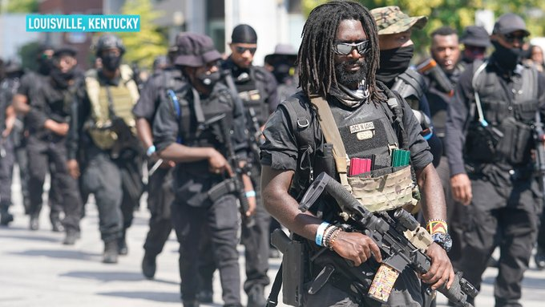

Members of an all-Black militia group called NFAC hold an armed rally in Louisville, Kentucky, U.S. July 25, 2020. A group of heavily armed Black protesters marched through Louisville, Kentucky on Saturday demanding justice for Breonna Taylor, a Black woman killed in March by police officers who burst into her apartment. REUTERS/Bryan Woolston

QUESTION

1. What was the purpose of the armed rally held by the all-Black militia group NFAC in Louisville, Kentucky?

a) To advocate for gun control reforms

b) To demand justice for Breonna Taylor

c) To support the police officers involved in Breonna Taylor's case

d) To protest against racial integration

Answer: b) To demand justice for Breonna Taylor

1. What event led to the formation of the NFAC and their subsequent armed rally in Louisville?

a) A police shooting in Chicago

b) The death of George Floyd in Minneapolis

c) The killing of Breonna Taylor in her apartment

d) A protest against education reforms

Answer: c) The killing of Breonna Taylor in her apartment

1. Where did the heavily armed Black protesters march through during their rally in Louisville?

a) Birmingham, Alabama

b) Louisville, Kentucky

c) Atlanta, Georgia

d) Chicago, Illinois

Answer: b) Louisville, Kentucky

1. NEWS ITEM

The definition of news item text is an English text that tells an important incident or event in a form that resembles news, or is worthy of being used as news. quoting from Create Webquest, “News item is a text which informs readers about events of the day. The events are considered newsworthy or important. It means if there is an important event that should be known by many people.”

Generic Structure of News Item Text:

1. **Main event/Newsworthy events**

Taking from the word "main" which means main, then "event" which means incident, then main event is a paragraph that contains a summary of an event, aka an important incident that is highlighted to be conveyed to the reader.

1. **Elaboration/Background Event**

This background event contains the background of the event that occurred. Starting from what and who was involved, where, when, why, and how the incident happened. This structure must be written in full so that readers can understand the entire text easily and the value of the news can be conveyed well.

1. **Resource of Information (Source)**

Source, namely the section that contains the opinions of experts or eyewitnesses. Apart from that, it can also be comments from various other parties involved.

The function of news item text is also known as social function, namely what is the purpose of writing a text for the general public. Well, this is nothing more than news item text which aims to provide information to readers about an important event or event that is of value.

The characteristics of news item text are as follows:

* The content of the text focuses on an important incident or event
* The language used is short but concise
* Sometimes it begins with the name of the city or the name of the media that publishes it. For example, Jakarta –….
* Usually accompanied by pictures/illustrations and titles (headlines) that describe the essence of the event

EXAMPLE

**Hundreds of thousands affected by floods, landslides as heaviest rain in 60 years hits southern China**

Almost half a million people have been affected by floods and landslides in the Chinese province of Guangdong, according to authorities, after parts of southern China were hit by the heaviest downpours in 60 years over the weekend.

Flooding caused by the torrential rain has forced 177,600 people to relocate, destroyed 1,729 houses, damaged 27.13 hectares of crop and caused losses of more than $250 million, Guangdong’s Department of Emergency Management said Tuesday.

Guangdong is one of at least seven provinces where the record rainfall has caused severe landslides and flooded roads, according to state media. In southwestern Guizhou province, swollen rivers spilled over roads, sweeping away cars and homes, videos on social media showed. The downpours come amid warnings by experts that extreme weather is becoming more frequent.

Precipitation in Guangxi, Guangdong and Fujian reached its highest since 1961, local weather bureaus said on Saturday, as those areas recorded an average rainfall of 621 millimeters (24.4 inches) in the 46 day period from May 1 and June 15, according to state news agency Xinhua.

That figure is equal to more than 90% of the countrywide average of 672.1 millimeters for the whole of 2021, based on data by the National Climate Center. Weather experts say conditions are ripe for further heavy rainstorms in the south of the country and heatwaves in the north.

“Cold and warm air has converged over southern China, and the two sides have entered a deadlock and a tug of war,” Wang Weiyue, an analyst at weather.com.cn, an arm of the China Meteorological Administration, told Reuters.

Heavy rain is forecast to persist until Tuesday in the southern provinces of Guizhou, Jiangxi, Anhui, Zhejiang and Guangxi and then move northward.

Adopted from CNN  
(<https://edition.cnn.com/2022/06/20/world/southern-china-southern-severe-flood-rain-climate-crisis-intl-hnk>)

QUESTION

1. What has been the estimated financial loss caused by floods and landslides in Guangdong province?

a) Over $100 million

b) Approximately $250 million

c) Less than $50 million

d) Close to $500 million

Answer: b) Approximately $250 million

1. How many people were forced to relocate due to flooding caused by torrential rain?

a) 27,000

b) 177,600

c) 500,000

d) 1,729

Answer: b) 177,600

1. Which provinces, aside from Guangdong, were mentioned to be affected by severe landslides and flooding due to record rainfall?

a) Four provinces

b) Five provinces

c) Six provinces

d) Seven provinces

Answer: d) Seven provinces

1. RECOUNT TEXT

The definition of recount text is a type of English text that retells events or incidents in the past. The story can be an action or activity before someone writes the text.

There are several purposes of recount text, namely:

1. **Provide information to readers**

Recount text can be used to provide information about an event or experience in the past to other people. In this case, the information could be a trip report, personal experience, or a report about an event.

1. **Entertain readers**

Like most other texts, recount text also functions to entertain readers. The reason is, this type of English text is generally written to tell something pleasant.

1. **Reflect on something**

In some cases, recount text can be used as a medium to reflect and analyze certain events or experiences. This is the reason why diaries and personal journals are included as recount text.

1. **Document important experiences**

Apart from photos and videos, you can also immortalize important experiences in the past through recount text.

1. **Study history**

In an educational context, recount text is often used to study and understand historical events.

There are three generic structures of recount text, namely orientation in the form of an introduction, series of events which contains a series of stories, and re-orientation which provides a summary and ending of the entire content of the story.

1. Orientation

Did you realize that most texts start with orientation. In Indonesian, it means orientation, aka introduction. Of course, the content of orientation is information about figures or characters, location, time of incident, etc.

1. Series of Events

Are you familiar with the word events? Yes, event is an event, while series means a series. In this section, the author will write a series of events that they experienced (the essence of recount text).

1. Re-orientation

In creating recount text, the ending of a story is called reorientation. In this section, the author will provide a summary and conclusion of the whole story as well as tell the ending (sad/happy). If there is, the author will also add impressions and messages for readers.

Recount text has two main characteristics, namely:

* In recount text there is no conflict in the story told by the author, in contrast to English narrative text which has conflict in its structure.
* There is always a chronological order of stories, for example there are stories on the first day, the second day, and so on.

The types of recount text consist of personal recount, factual recount, imaginative recount, and historical recount. Here's the explanation:

1. Personal Recount Text

Personal recount text is a type of text that aims to tell about the writer's personal experiences. Personal recount is the most common type that is often found in recount writing.

2. Factual Recount Text

Have you ever heard of this type of text? Factual recount text is a story to present a report regarding events that occurred based on facts (actually happened). So, this is not focused on personal events, it could also be other people's events. Examples include reports about science experiments a.k.a science or police reports.

3. Imaginative Recount Text

Not only narrative text, recount text also has an imaginative type. Imaginative recount is a text that someone usually uses as a story of an imaginative event that someone experienced. For example, recount text tells the author's experience regarding the imagination he had from a dream.

4. Historical Recount Text

Historical recount text is a form of recount text whose content tells historical events. In essence, this text is a historical story in English. Eits, but differentiate it from narrative. In narrative, it is imaginary. Meanwhile, in recount text, the history being told actually happened in the past. For example, regarding the proclamation of Indonesian independence.

EXAMPLE

**Empowering Underprivileged Children Through Technology on Children’s Day 1999**

On Children’s Day in 1999, a technology company treated more than 200 underprivileged children to a ‘high-tech’ experience. They were given training on information technology. The company wanted to provide opportunities for these children to learn more about the Internet and the latest technology. They wanted to help the less fortunate in the community.

The children had an enjoyable and educational experience that day. They were exposed to the new technology for the first time and they were very interested. The company hoped to conduct many more such training sessions for these children. They felt that the skills the children had would be useful to them when they grew up.

The company was very active in caring for the less fortunate. They even put aside one day a year for their employees to do volunteer work to help the needy. They also donated money to many charitable organizations. Many people had benefited from their efforts. Many also praised the company for being so generous towards the needy.

QUESTION

1. What did the technology company do for over 200 underprivileged children on Children’s Day in 1999?

a) They organized a sports event

b) They provided training in information technology

c) They distributed free books

d) They hosted a music concert

Answer: b) They provided training in information technology

1. Why did the company offer training on the Internet and the latest technology to the underprivileged children?

a) To entertain them on Children’s Day

b) To provide opportunities for learning

c) To advertise their technology products

d) To conduct a social experiment

Answer: b) To provide opportunities for learning

1. How did the children react to the new technology they were exposed to?

a) They were disinterested

b) They were scared

c) They were very interested

d) They were hesitant

Answer: c) They were very interested

***EXPRESSION***

1. SAYING THANK

The English language can be pretty challenging, including even the simplest expressions, such as giving thanks. That’s because there are many ways to say thank you, and you're welcome in English.

The context in which you use each expression is extremely important to make it appropriate. You wouldn't want to use an excessively familiar phrase among colleagues at work, for instance, because it would sound too casual. And on the other hand, if a family member said one of those phrases to you, it could sound overly formal and even disrespectful.

Learning to say “thank you” and “you're welcome” in English is essential for social skills and for your success, whether you're a native speaker or not. Here’s why.

* **It’s important to show gratitude.**

If someone does something for you or gives you a gift, it's natural to say "thank you." It doesn't matter how big or small whatever they did for you is. Saying "thank you" shows that you appreciate their efforts. Knowing different English expressions to say “thank you” will make it easier for you to express your gratitude and appreciation appropriately in any situation.

* **It’s polite.**

Of course, “thank you” is one of the first phrases our parents taught us when we were little kids. Why? Well, because saying “thank you” is simply polite - and being polite is essential in most cultures. Still, it's especially so in English-speaking countries. The more polite words and phrases you know, the better your English will sound.

* **It’s a social norm.**

Saying “thank you” is a basic necessity, no matter where you live. There are definite social expectations for doing so, and breaking those expectations can sometimes lead to misunderstandings. In some countries, not saying “thank you” in certain situations means being rude. And you definitely don’t want to come off as a rude person!

**How to say thank you in English**

A less formal way to say “thank you” in English is “thanks.” If you're expressing gratitude to someone you have a formal relationship with, such as your boss or the call center agent you’re talking to on the phone, then "thank you" is the polite way to do it. If you're thanking someone you know, such as a friend or your mum, the more informal version of "thanks" is the best option.

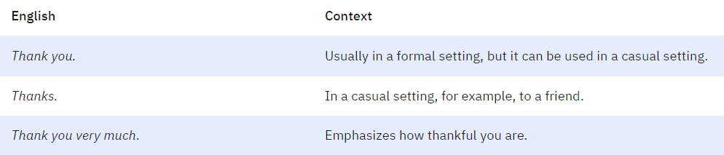

**How to say thank you in English formally**

When you’re in a formal setting, such as in a business meeting or when talking to your boss, you want to be very careful with the language you’re using to express yourself. While expressing your gratitude is essential, if you do it in a way that is not appropriate for a formal setting, you might come across as unprofessional.

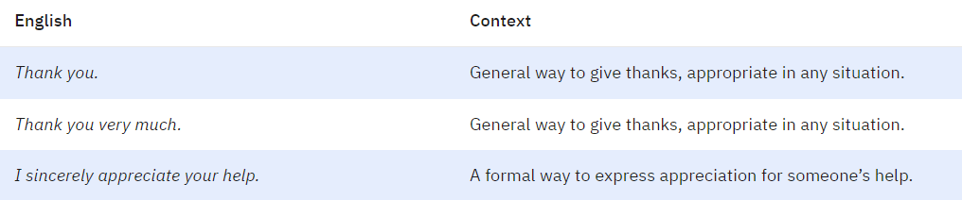

EXERCISE

1. Why is it important to know different English expressions for saying “thank you”?

a) To confuse others in social situations

b) To avoid expressing gratitude

c) To accurately express gratitude in various contexts

d) To disregard social norms

Answer: c) To accurately express gratitude in various contexts

1. What does the passage highlight about saying “thank you” in English-speaking countries?

a) It is unnecessary

b) It is informal

c) It is optional

d) It is considered polite

Answer: d) It is considered polite

1. Which phrase is suggested for expressing gratitude in a formal setting, like a business meeting?

a) “Thanks a bunch!”

b) “Thank you kindly.”

c) “Cheers!”

d) “Thanks, mate!”

Answer: b) “Thank you kindly.”

1. SAYING SYMPHATY

Expressing sympathy is an important part of human interaction, especially in difficult times. Whether it's the loss of a loved one, a personal setback, or a global crisis, showing sympathy can provide comfort and support to those who are struggling.

We've all been there. Someone you know is going through a difficult time. They are sad, or depressed, or even depressed. You want to say something to let them know you care, but it can be awkward. What are the correct words?

**Basic Vocabulary for Expressing Sympathy**

When someone we know is going through a difficult time, it’s important to express our sympathy and offer support. Here are some common phrases and appropriate adjectives to use when expressing sympathy:

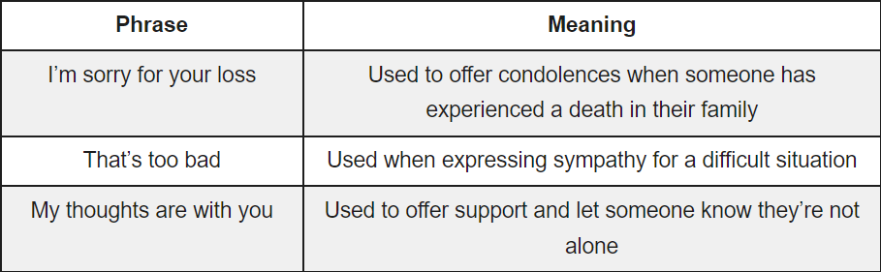

**Appropriate Adjectives and Their Usage**

When expressing sympathy, it’s important to use appropriate adjectives to convey your emotions. Here are some common adjectives and their usage:

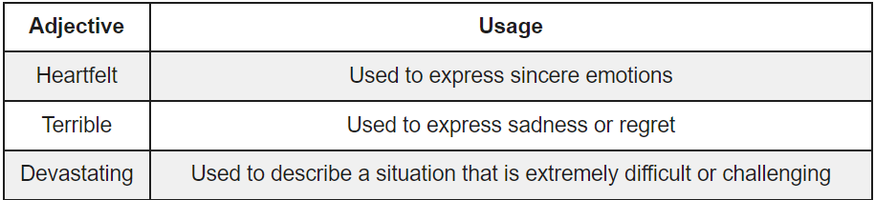

By using these common phrases and appropriate adjectives, we can express our sympathy and offer support to those who are going through a difficult time. Remember, it’s important to be sincere and genuine when expressing sympathy, and to offer support in any way we can.

EXERCISE

1. Why is expressing sympathy considered significant in human interaction during tough times?

a) It can be awkward

b) It's essential for showing discomfort

c) It provides comfort and support

d) It creates distance between individuals

Answer: c) It provides comfort and support

1. What role do appropriate adjectives play when expressing sympathy?

a) They're unnecessary in expressing emotions

b) They convey emotions effectively

c) They create confusion in communication

d) They hinder emotional expression

Answer: b) They convey emotions effectively

1. Why is sincerity emphasized when expressing sympathy?

a) To distance oneself from the situation

b) To appear disinterested

c) To offer genuine support and care

d) To avoid expressing emotions

Answer: c) To offer genuine support and care

1. CONGRATULATIONS

**Understanding Expressions of Congratulations**

Expression of Congratulations is an expression used to congratulate someone who has succeeded in achieving their goals. Congratulations have the same meaning as the word good wishes. This means giving appreciation or good wishes to someone.

**Types of Expressions of Congratulations**

There are several expressions that can be used to say congratulations in English. These congratulations are divided into two, namely congratulations for achievements and congratulations for celebrations.

**Function of Expression of Congratulations**

The function of expressions of congratulations is to show a feeling of pleasure or pride in other people's achievements or accomplishments. By saying congratulations, we can provide support and motivation to that person to continue trying and developing. Apart from that, congratulations can also strengthen the relationship between us and the people we congratulate.

**Congratulations for Achievement**

Congratulations for achievements are divided into two, namely formal and informal greetings. Formal expressions of congratulations are usually used in written form or in letters. However, it can also be used on other occasions but still in formal situations. Here's an example:

* Congratulations!
* Congratulations on...
* I'd like to congratulate you on…
* I'm happy for you!
* I am happy for your success on…

So, to make it cooler and more relaxed, you can also use informal congratulations in your daily interactions. Here's how:

* Congratulations!
* GG or Good Game (used in games)
* Three cheers! (used while making a toast)

**Congratulations for Celebrations**

If the previous congratulations were used for achievements, this congratulation is an example of congratulations for special days that take the form of a celebration (event-based expression)2. Congratulations for celebrations must be appropriate to the situation. Usually, this congratulation begins with the word "happy". Here's an example:

* Happy birthday! (Happy birthday)
* Happy anniversary! (Happy Anniversary)
* Happy New Year! (Happy New Year)
* Happy Eid al-Fitr! (Happy Eid al-Fitr)

EXERCISE

1. What is the primary purpose of expressions of congratulations?

a) To express sympathy and sorrow

b) To convey disappointment and dissatisfaction

c) To show pleasure and pride in someone's achievements

d) To criticize and discourage

Answer: c) To show pleasure and pride in someone's achievements

1. What is the function of saying congratulations according to the passage?

a) To discourage further efforts

b) To show support and motivation

c) To create distance in relationships

d) To withhold appreciation

Answer: b) To show support and motivation

1. Which expression is appropriate for congratulating someone on their success in a more relaxed manner?

a) "Good Game!"

b) "Happy Anniversary!"

c) "I'd like to congratulate you on..."

d) "Happy New Year!"

Answer: a) "Good Game!"

1. FEELING HAPPINESS

Whenever something good happens in our lives, we want to express our happiness and joy. But sometimes it can be tricky to find the right words to capture those feelings.

There are generally three types of expressions of happiness. The first is the idiom, which is a phrase that has a meaning that is not literal. Second are quotes, which are phrases said by famous or well-known people. Third are sayings, which are phrases that have become popular over time.

An **expression of happiness** is a phrase or saying that captures a feeling.

An **expression of happiness** is also any phrase that communicates a feeling of happiness, excitement or joy. They are often words that can be easily understood.

**Happiness** is also a state of mind, but there are several words that can be used to talk about the circumstances, causes, or intensity of pleasure.

here are some ‘words’ which are known as synonyms associated with happiness and joy:

* **Bliss** – Unconditional happiness.
* **Laughter** – Emotion of overwhelming happiness and humor.
* **Elation** – Being ‘over the moon’ type of feelings.

idioms for happiness expressions are as follows:

* To feel on top of the world: to feel extremely happy
* To be in seventh heaven: to be very happy
* To jump for joy: to feel great happiness and show it by jumping up and down

Here are some phrases that express happiness:

* to be over the moon: to be very happy
* to have a whale of a time: to have a great time
* to be in high spirits: to be very happy and full of energy

EXERCISE

1. What are the three types of expressions of happiness mentioned in the passage?

a) Idioms, proverbs, and quotes

b) Quotes, sayings, and proverbs

c) Idioms, quotes, and sayings

d) Proverbs, idioms, and sayings

Answer: c) Idioms, quotes, and sayings

1. How is an idiom defined in the context of expressing happiness?

a) A literal phrase conveying a feeling

b) A phrase said by famous personalities

c) A phrase with a non-literal meaning

d) A phrase popularized over time

Answer: c) A phrase with a non-literal meaning

1. Which phrase expresses the idea of having a great time?

a) "To be over the moon"

b) "To be in high spirits"

c) "To have a whale of a time"

d) "To feel on top of the world"

Answer: c) "To have a whale of a time"

***GRAMMAR/LANGUAGE FEATURE***

1. PARAGRAPH

A paragraph is a distinct section of writing covering one topic. A paragraph will usually contain more than one sentence. A typical paragraph will be 5-7 sentences, but this is by no means a rule. The length is determined by the topic and the content.

The "perfect" paragraph will start with a topic sentence. It will have detail sentences in the middle and end with a concluding sentence. It will only cover one topic from start to finish.

**Indenting or Numbering Paragraphs**

A paragraph starts on a new line. Sometimes, paragraphs are indented or numbered. (Whatever format you use, be consistent.)

A paragraph could be part of a text that informs people, describes something, critiques something, compares things, persuades people, lists a process, makes an argument, offers a solution, or narrates a story. The level of detail will vary from text to text, so there is no answer to the question "how long is a paragraph?".

There are three noteworthy points related to paragraphs. One is a good tip, one is a style convention, and one is an observation.

* In business writing, use paragraph titles.

A good tip for business writing is to give each of your paragraphs a title that summarizes the paragraph content. This serves two purposes. Firstly, it ensures your paragraph topic is neatly bounded, and, secondly, the title will assist busy executives with skim-reading.

* Use several "opening" quotation marks if your quotation covers more than one paragraph.

When a quotation contains multiple paragraphs (or is a text with lots of new lines), a common convention is to use an opening quotation mark at the start of each paragraph (to remind your readers that they're still reading a quotation) but only one closing quotation mark at the end of the last paragraph.

* Your online readers won't read lengthy texts, so use your discretion to keep your paragraphs short.

In print, an unbroken lengthy text looks dull and daunting. On a screen, an unbroken lengthy text looks doubly so. Therefore, dividing a long text into bite-sized topics is essential for keeping your readers engaged. If we're being strict, each of your paragraphs should neatly encapsulate one topic, but, as we've touched upon, the definition of "topic" is pretty slack, and this often gives you some wriggle-room to play with your paragraph lengths.

EXERCISE

1. What constitutes the structure of a "perfect" paragraph?

a) Beginning with a topic sentence, followed by multiple concluding sentences

b) Beginning with a concluding sentence, followed by multiple detail sentences

c) Starting with a topic sentence, including detail sentences, and ending with a concluding sentence

d) Starting with a conclusion, followed by a topic sentence and detail sentences

Answer: c) Starting with a topic sentence, including detail sentences, and ending with a concluding sentence

1. What is suggested regarding the length of paragraphs for online readers?

a) Longer paragraphs are preferable for online reading

b) Short paragraphs are recommended for online engagement

c) Paragraph length does not affect online readers

d) Use excessively lengthy paragraphs for online content

Answer: b) Short paragraphs are recommended for online engagement

1. How can paragraph titles be advantageous in business writing?

a) To complicate paragraph structure

b) To summarize paragraph content and aid in skim-reading

c) To confuse busy executives

d) To eliminate the need for paragraph structure

Answer: b) To summarize paragraph content and aid in skim-reading

1. NOUN PHRASES

In the English language, nouns are the words used to refer to people, places, or things. A noun phrase is a group of words, usually a noun in addition to a modifier—such as an adjective, adverb, or article—that functions just as a noun would. Grammatically, a noun phrase can be the subject, object, subject complement, or object complement in the sentence in which it appears.

According to English grammar rules. There are two broad categories of noun phrases: those with premodifiers and those with postmodifiers.

* **Noun phrases with premodifiers**: As the names suggest, premodifiers are words that come before the noun in the noun phrase. These words are typically adjectives, participles, articles, possessive nouns, possessive pronouns, and compound nouns.
* **Noun phrases with postmodifier**: Noun phrases can include other phrases, such as prepositional, participle, and compound phrases, as well as relative clauses. When this occurs, the additional words tend to come after the noun, meaning they are postmodifiers. Infinitives and relative clauses are other postmodifiers.

A noun clause has a noun and a verb. In other words, a noun clause has a subject and a predicate, like a sentence, but because it is dependent, it doesn’t express a complete thought. A noun phrase is a group of words that includes a noun.

EXERCISE

1. What is a noun phrase, and how does it function in a sentence?

a) A phrase containing only a noun with no modifiers, functioning as the subject or object

b) A group of words containing a noun and modifiers, functioning as a sentence's subject, object, or complement

c) A phrase with multiple verbs but no nouns, functioning as an adverbial phrase

d) A phrase exclusively used as a subject in a sentence

Answer: b) A group of words containing a noun and modifiers, functioning as a sentence's subject, object, or complement

1. What is the grammatical role of the noun phrase "Most scientists" in the sentence "Most scientists agree that drastic action must be taken immediately"?

a) Indirect object

b) Direct object

c) Subject

d) Adverbial phrase

Answer: c) Subject

1. Which sentence features a noun phrase functioning as an adverbial?

a) “They fought like tigers.”

b) “The pitcher threw a blistering fastball.”

c) “A blue crab crawled sideways across the beach.”

d) “The hat that was found at the crime scene was a major clue.”

Answer: a) “They fought like tigers.”

1. NOUN CLAUSE

A noun clause is a type of subordinate clause (dependent clause) that acts as a noun in a sentence. Most of the time noun clauses begin with a relative pronoun like what or whatever. In this noun clause example, “I like who you are,” the noun clause “who you are” acts as a single noun, specifically the direct object for the verb like.

A noun clause gets its name because it is simply a clause that acts like a noun. A clause is any group of words that contains both a subject and a verb, but noun clauses are a specific type of clause called a subordinate clause.

Also known as dependent clauses, subordinate clauses cannot be used alone and need to join an independent clause. That means sentences with noun clauses will always have at least two verbs (because they will always have two clauses). Let’s look at a noun clause example:

*“Whoever wrote the graffiti needs grammar lessons.”*

This sentence has two clauses: an independent clause and a noun clause. The noun clause is the phrase “whoever wrote the graffiti”; this group of words work together as a single noun and include both a subject (whoever) and a verb (wrote).

Noun clauses can do anything a regular noun can do. This means they can act as a:

* subject
* direct object
* indirect object
* prepositional object
* predicate nominative

Noun clauses completely replace individual nouns in a sentence, no matter how long the noun clauses are or how many words they contain. For example, let’s look at a sentence without a noun clause.

Noun clauses are fairly easy to recognize if you know what they start with. Noun clauses can begin with relative pronouns and certain subordinating conjunctions. Here’s a list of common words that begin noun clauses to help you identify them when reading or use them when writing.

Relative pronouns

* who
* what
* where
* when
* why
* how
* that
* which

Indefinite relative pronouns

* whoever
* whomever
* whatever
* wherever
* whenever
* whichever

Subordinating conjunctions

* if
* whether

EXERCISE

1. What defines a noun clause within a sentence?

a) A clause that always starts with a preposition and functions as an adverb

b) A subordinate clause acting as a noun and containing a subject and a verb

c) An independent clause acting as the main subject in a sentence

d) A clause formed only with a relative pronoun and functioning as an object

Answer: b) A subordinate clause acting as a noun and containing a subject and a verb

1. How can a noun clause be identified in a sentence?

a) They always start with adverbs or adverbial phrases

b) They never contain relative pronouns or subordinating conjunctions

c) They typically include only one verb and one subject

d) They start with relative pronouns or certain subordinating conjunctions

Answer: d) They start with relative pronouns or certain subordinating conjunctions

1. In which sentence does the noun clause act as an indirect object?

a) "She told whoever would listen her sad story."

b) "Look for open teammates; don’t just pass whoever is closest the ball."

c) "The chess player didn’t know if they could win."

d) "I couldn’t see whether it was day or night."

Answer: b) "Look for open teammates; don’t just pass whoever is closest the ball."

1. ABSTRACT NOUNS

Nouns in general represent things (including people, places, objects, and ideas). But some things aren’t actually things! Ideas, emotions, personality traits, and philosophical concepts don’t exist in the physical world—you can’t sense them or interact with them—so we call them abstract nouns to differentiate them from concrete nouns.

**Abstract nouns vs. concrete nouns**

We dive deep into abstract nouns vs. concrete nouns here, but there’s a quick and easy way to tell them apart. If you can see, hear, taste, smell, or touch it, then it’s a concrete noun. If you can’t, then it’s an abstract noun.

Consider the difference between anger, an abstract noun, and chair, a concrete noun. You can touch a chair and see a chair, but you can’t touch or see anger itself. (Even though you can use your five senses to perceive the signs of anger, such as seeing a red face or hearing a gruff tone.)

By default, proper nouns are never abstract nouns. Proper nouns like the Empire State Building, Kathmandu, or Mister Rogers represent things that are specific and tangible. However, this can get confusing if a philosophical idea is derived from a proper noun. For example, Karl Marx is a proper noun, but Marxism is an abstract noun, even though it’s still capitalized.

As we’ve said, abstract nouns can be hard to describe because they elude the senses. Sometimes it’s better to see examples to understand. (Some of these can also double as verbs, especially the emotions, so pay attention to how they’re used in the sentence.)

Idea:

* life
* death
* humor

Emotions

* love
* hatred
* happiness

Personality traits

* courage
* loyalty
* compassion

EXERCISE

1. How do abstract nouns differ from concrete nouns?

a) Abstract nouns can be perceived through the five senses, while concrete nouns cannot.

b) Abstract nouns represent tangible and specific things, while concrete nouns represent ideas and emotions.

c) Concrete nouns are always proper nouns, while abstract nouns are not.

d) Abstract nouns are tangible, while concrete nouns are intangible.

Answer: a) Abstract nouns can be perceived through the five senses, while concrete nouns cannot.

1. Which of the following is an example of an abstract noun?

a) Chair

b) Empire State Building

c) Happiness

d) Kathmandu

Answer: c) Happiness

1. Which category includes concepts that cannot be experienced through the five senses?

a) Concrete nouns

b) Proper nouns

c) Abstract nouns

d) Adjective nouns

Answer: c) Abstract nouns